BACKGROUND NARRATIVE

Cancer causes nearly 16% of deaths worldwide, thus research into treatments for and understanding the process of cancer development is critical. Cancer is defined by abnormal and detrimental proliferation of a cell such that it places stress on the system for resources and destroys or invades neighbouring tissues. There are multiple and diverse methods of treating cancer, including surgery, chemotherapy and radiotherapy. The purpose of our project became identifying a particular protein network and through the use of mathematical modelling determine interactions and proteins that could serve as potential targets for cancer treatment

Our project began with a discussion on the most important aspects of the cell, in order to determine which networks were best to investigate. Between the maths and biochemistry students, discussion turned towards cancer, defined by aberrant cell cycle activity occurring due to mutations in signalling pathways or the genes encoding cell cycle proteins. The cell cycle is a tightly regulated process and is integral to an organism’s livelihood. The biochemistry students put forward CDK4, which forms a complex with cyclin D1 to manage the transition between G1 and S phase of the cell cycle. CDK4 is activated by mitotic growth factors and triggers the transition through two mechanism; phosphorylation of the retinoblastoma tumour suppressor protein, which enables E2F transcription factors to activate S phase genes, and sequestering p21/p27 to remove its inhibitory effect on the cyclin E/CDK2 complex. This process can be seen in figure 1, which was generated by one of the biochemistry students to cohesively understand CDK4’s role in the cell cycle. We also generated a sketchfab of the CDK4 structure to help us understand how the proteins structure influences its function (<https://skfb.ly/6Wtvz>)

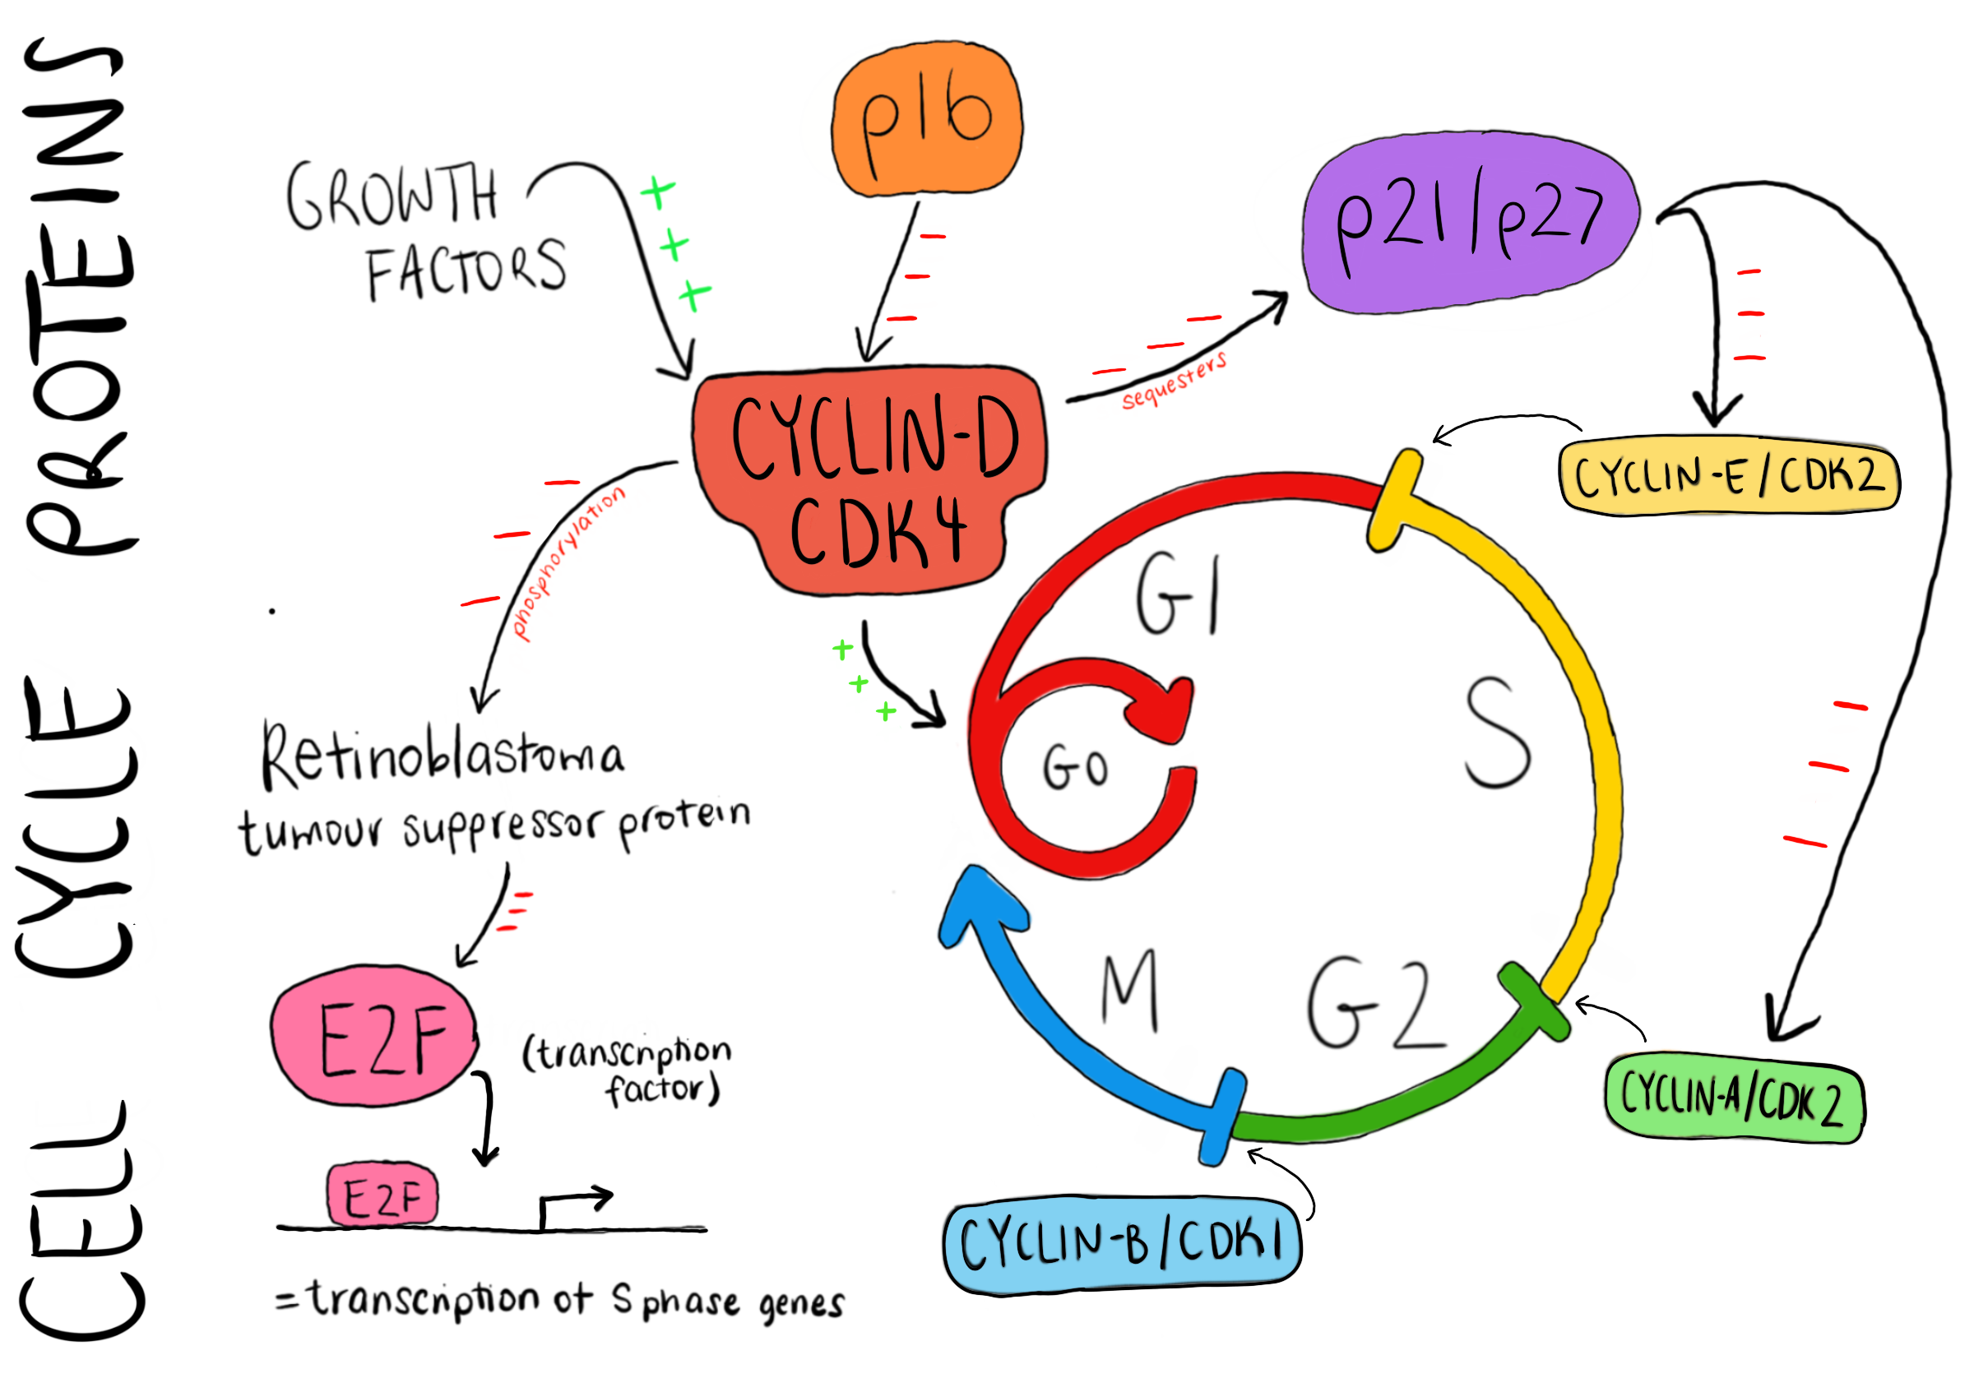

Figure 1: Illustrative schematic of CDK4/Cyclin D complex’s role in the cell cycle.

Next, we validated CDK4 as a relevant target for our overall investigation: is it implicated in cancer and how? A brief literature review, found in table 1, revealed that CDK4 is implemented in several cancers including mammary carcinomas and intestinal adenomas. Overexpression of CDK4, along with its cyclin partner cyclin D1, is consistently associated with an increase in carcinoma initiation and tumorigenesis, as well as the maintenance of aberrant proliferation. With CDK4 established as an integral protein in our area of question, we decided on CDK4 as our protein of interest and the central node for our network analyses.

*Table 1: Literature Summary of Journal Articles Examining role of CDK4 in various cancers. This table illustrates that CDK4 in implicated in multiple cancers and is therefore a good target for cancer treatment research*

|  |  |  |  |
| --- | --- | --- | --- |
| **Paper** | **Cancer Type** | **Outcomes** | **Conclusions** |
| *Requirement for CDK4 Kinase Function in Breast Cancer* [1] | Mammary Carcinomas triggered by ErbB-2 oncogene | **1.** CDK4 is not required for normal mammary epithelial development  **2.** Wild-type - cyclin D1 associates with CDK4, CDK6, CDK2 and p27, CDK4 -/- associates with CDK6, CDK2, p27 ➝ cyclin D1 retains ability to titrate p27 without CDK4  **3.** CDK4 -/- do not develop mammary carcinomas ➝ interaction between D1 and CDK4 required for tumorigenesis  **4.** Kinase deficient cyclin D1 (can bind to CDK4 but cannot activate kinase activity) mice are resistant to breast cancers driven by ErbB-2 ➝ Cyclin D1-CDK4 kinase activity is required  **5.** Increase in cyclin D1-CDK4 levels is much greater than associate kinase activity ➝ tumour cells rely on complexes to drive cell proliferation  **6.** Knockdown of CDK4 blocks ability of cells to form tumours ➝ CDK4 required for cell proliferation (initiation and maintenance) (similar results for cyclin D1 knockdown)  **7.** Cells expressing kinase-dead human CDK4 unable to efficiently form tumors ➝ kinase activity required for initiation of breast cancers and to maintain proliferation | CDK4 kinase activity is integral to the initiation and maintenance of breast cancer driven by the ErbB-2 oncogene  Patients bearing this type of breast cancer might benefit from pharmacological blocking of CDK4 kinase activity |
| *Cyclins and Cyclin Dependent Kinases: comparative study of hepatocellular carcinoma versus cirrhosis* [2] | Hepatocellular Carcinoma (HCC) | **1.** Overexpression of cyclins D1, E and A, and CDK4 was detected in preneoplastic and neoplastic liver of long evans cinnamon rats (HCC animal model)  **2.** Overexpression of D1, E and A messenger RNA and protein, and overexpression of cyclin D/CDK4 and cyclin E/CDK2 complexes occurs in HCC of chemically induced  **3.** Cyclin D1 related kinase activity markedly enhanced in HCCs  **4.** CDK4 activity in poorly differentiated HCCs is higher than that in non tumours ➝ increase in cyclin D1 / CDK4 may be associated with transition from hepatitis C induced cirrhosis to HCC  **5.** Hepatitis C Virus core protein acts as a promoter of cell growth by repressing transcription of CDK inhibitor, p21  **6.** CDK4 mapped to chromosome 12 close to proto-oncogene MDM2 | Activation of cyclin De, CDK4, cyclin E, cyclin A may play important roles in the process of malignant transformation of cirrhosis  Up regulation of cyclin D1, CDK4 and cyclin E shown to be related to differentiation and progression of HCC  Inhibition of cyclin D1, CDK4 and cyclin E may provide novel strategy for suppression of development of HCC |
| *Cyclin D1-CDK4 complex, a possible critical factor for cell proliferation and prognosis in laryngeal squamous cell carcinomas,* [3] | Laryngeal Squamous Cell Carcinomas | **1.** In 102 patients, 57.8% and 47.1% showed cyclin D1 and CDK4 overexpression respectively  **2.** Showed cyclin D1 and CDK4 overexpression in LSCC compared with normal adjacent tissue  **3.** Abnormal upregulation of cyclin D1 and CDK4 contributes to malignant progression  **4.** High expression of cyclin D1 and CDK4 associated with high PCNA index (marker of cell proliferation)  **5.** CDK4 overexpression is associated with a poor prognosis and poor overall survival | Overexpression of cyclin D1-CDK4 complex could be associated with cancer cell proliferation: may promote cancer cells towards more advanced stages and cause stronger invasion into deeper tissues or lymphatic system as well as poor clinical outcome |
| *Concurrent overexpression of cyclin D1 and cyclin dependent kinase 4 (CDK4) in intestinal adenomas from multiple intestinal neoplasia (Min) mice and human familial adenomatous polyposis patients* [4] | Intestinal adenomas associated with familial adenomatous | **1.** Co-expression of cyclin D1 and CDK4 was accompanied by a significant increase in the number of proliferating cells within the adenomas  **2.** Increased levels of cyclin D1 and CDK4 in 69% of adenomas compared with adjacent grossly normal colonic mucosa  **3.** CDK4 expression is inappropriately increased in ectopic location (adenomatous epithelium) | Result strongly suggest a relationship between overexpression of cyclin D1, inappropriate expression of CDK4 and the increased cell proliferation that was observed in intestinal adenomas  Coexpression of cyclin D1 and CDK4 occur at the relatively early premalignant stage of tumour development in the intestine. This expression may account for increased cell proliferation and autonomous growth of intestinal adenomas. |
| *Germline mutations in the p16INK4abinding domain of CDK4 in familial melanoma* | Melanoma | **1.** Arg24Cys mutation in CDK4 found in two unrelated melanoma families which do not carry germline p16INK4amutations  **2.** Mutation has specific effect of p16INK4abinding domain of CDK4, but has no effect on its ability to bind cyclin D and form a functional kinase | Arg24Cys mutation in CDK4 generates a dominant oncogene that is resistant to normal physiological inhibition by p16INK4a |

With CDK4 resolved as our protein of interest, we next needed to determine a yeast homolog so that we could utilise both experimental assays and network analysis to further our understanding of CDK4’s importance for the cell. Yeastmine.yeastgenome.org was used to find the homolog YBR160W, which is also referred to as CDC28. A sequence alignment done through uniprot.org, shown in figure 3, of human CDK4 and CDC28 revealed high homology, most importantly a similar binding and active site. Sketchfab was also used to assess these differences and compare the homologs (<https://skfb.ly/6Wtqn>  )

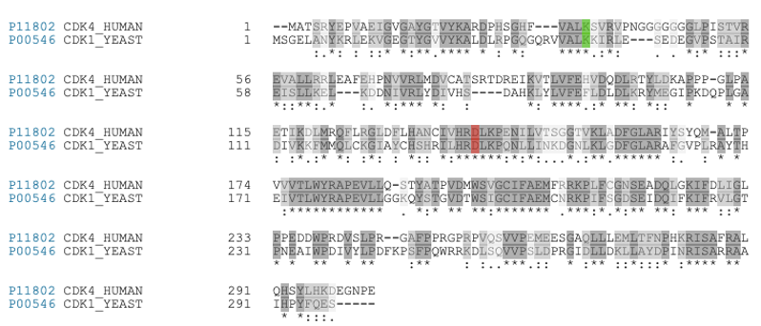

Figure 2: Sequence alignment of CDK4_Human gene and its yeast homolog, using Uniprot sequence analysis. Active site = red, Binding site = green, similarity = grey (lighter grey=less similar).

The next stage of our project then took the route of initial network analysis.

1. *Community Detection*
2. *Finding interesting nodes by centrality in each communities*
3. *Path analysis*

REFERENCES

1. Yu Q, Sicinska E, Geng Y, Ahnström M, Zagozdzon A, Kong Y et al. Requirement for CDK4 kinase function in breast cancer. Cancer Cell. 2006;9(1):23-32.
2. Masaki T. Cyclins and cyclin-dependent kinases: Comparative study of hepatocellular carcinoma versus cirrhosis. Hepatology. 2003;37(3):534-543.
3. Dong Y, Sui L, Sugimoto K, Tai Y, Tokuda M. Cyclin D1-CDK4 complex, a possible critical factor for cell proliferation and prognosis in laryngeal squamous cell carcinomas. International Journal of Cancer. 2001;95(4):209-215.
4. Zhang T, Nanney LB, Luongo C, Lamps L, Heppner KJ, DuBois RN, Beauchamp RD. Concurrent overexpression of cyclin D1 and cyclin-dependent kinase 4 (Cdk4) in intestinal adenomas from multiple intestinal neoplasia (Min) mice and human familial adenomatous polyposis patients. Cancer Res. 1997 Jan 1;57(1):169-75. PMID: 8988060.

Wolfel T, Hauer M, Schneider J, Serrano M, Wolfel C, Klehmann-Hieb E et al. A p16INK4a-insensitive CDK4 mutant targeted by cytolytic T lymphocytes in a human melanoma. Science. 1995;269(5228):1281-1284.

 11. Zuo L, Weger J, Yang Q, Goldstein A, Tucker M, Walker G et al. Germline mutations in the p16INK4a binding domain of CDK4 in familial melanoma. Nature Genetics. 1996;12(1):97-99.

 12. Guldberg P, Kirkin A, Grønbæk K, thor Straten P, Ahrenkiel V, Zeuthen J. Complete scanning of theCDK4 gene by denaturing gradient gel electrophoresis: A novel missense mutation but low overall frequency of mutations in sporadic metastatic malignant melanoma. International Journal of Cancer. 1997;72(5):780-783